Rendez-vous Bookstore Cafe

R.B.C

By: Elshaddai Akindele

Summary

R.B.C is a website that helps clients enjoy finding a book of their choice with coffee suggestions to compliment the read of the day/week or month. With the pandemic many are looking for new ways to keep themselves busy . R.B.C hopes to bring different experiences to reading.

Finding books the old fashion way can be discouraging to those who are still discovering what are their favourite books to read from sci-fi to Bibliographies. With R.B.C we had made the search much easier. With the suggestion of a type of coffee to drink to compliment the book

The Goal is to find a good book with a good cup of coffee

I'll be working on this project alone. I'll create the design and locate the appropriate API’s to create the site with the help of some tools such as HTML ,Javascript, github,MongoDB ,express,NODE.js ,client server ,MYSQL.

Working on this assignment was challenging as I did the work alone and I'm still learning and practicing some of my skills. Team work gives the opportunity to ask for some help and support

Improvements

The site is missing components such as the styling and being able to deploy on Heroku. A concept I would have loved to integrate in this application is the idea behind PWA where clients are able to look over at the books they would like to read while being offline and being able to keep a storage of previous coffees they had liked in the past.

Technical expertise

As i'm still learning how to make a full stack application on my own, I was able to understand how to make an index.js and app.js. The application needs to be installed by typing NPM start in the terminal. In order to be able to display the coffee choices <https://coffee.alexflipnote.dev/random.json>

And for the book api there's a few options such as using google Books API

Product pitch there's currently no other application that promotes drinking coffee and reading at the same time this is a great application for millennials and gen z. Who are known for drinking a lot of coffee. I think in the future I would like to integrate this application with the ability to create a virtual book club where users can discuss books together while drinking their favourite coffee.

Technical contribution

Was done all by myself

I would i loved for application to look like this application

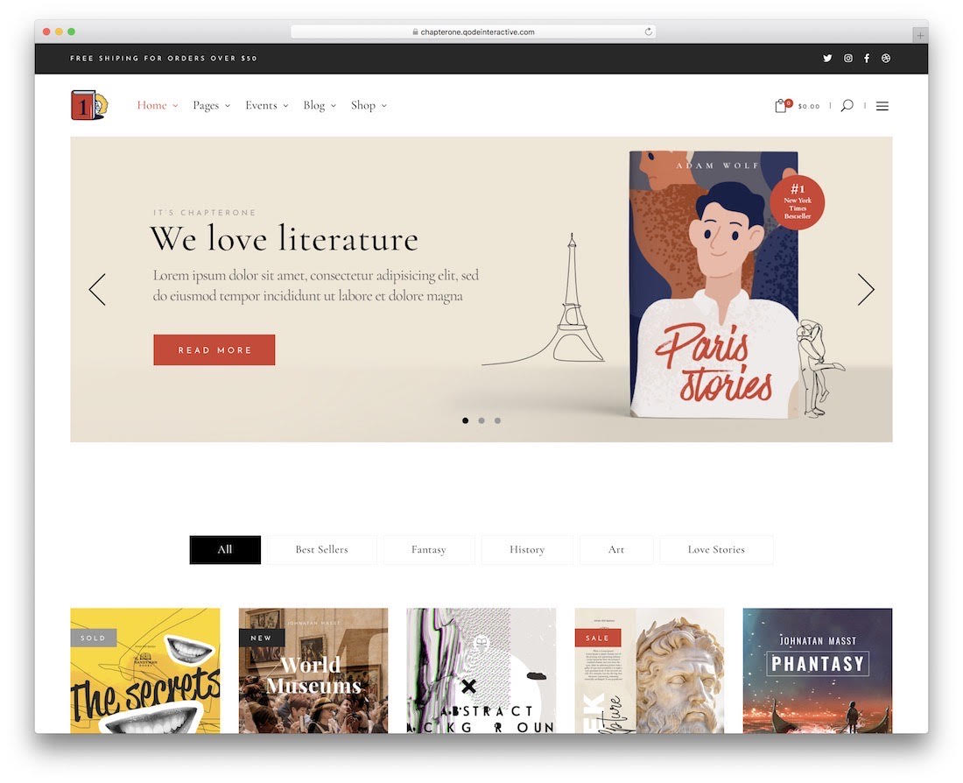

Where clients are able to search for books but all have the ability to select different book genres.